

|  |  |
| --- | --- |
| **Student Name/ID Number:** | Muhammad Kemal / BDSE07-0922-084 |
| **Academic Year:** | 2023 |
| **Unit Assessor:** | Ei Thandar Khaing |
| **Project Title:** | Power BI Data Preparation and Data Transformation |
| **Issue Date:** | Nov 11, 2023 |
| **Submission Date:** |  |

|  |
| --- |
| **Learner declaration** |
| I certify that the work submitted for this assignment is my own and research sources are fully acknowledged.  Student signature:  Date: |

**Task 1: Retrieve Total confirmed cases, daily deaths, daily cases as number**

Familiarize yourself with the visualizations by drag and drop the total confirmed cases that retrieves

all confirmed cases. Make the visual as CARD to get the total number. Repeat the same step for daily

deaths, daily cases also.

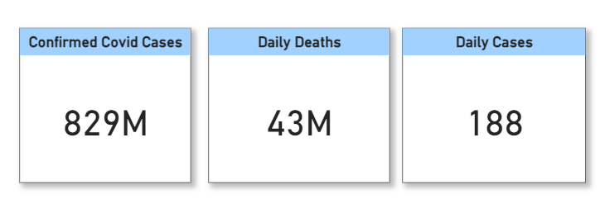

**Task 2: Retrieve Total confirmed cases by Month**

Create a LINE CHART visual of all confirmed cases by month field that includes the month, day under

AXIS and total confirmed cases under VALUES.

1. You can do your own formatting of font size, Data color, title, background
2. Make sure border is ON under formatting

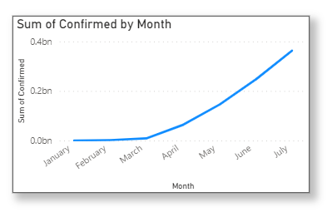

**Task 3: Retrieve Daily cases by Month**

Create a LINE CHART visual of all daily cases by month field that includes the month, day under AXIS

and daily cases under VALUES

1. You can do your own formatting of font size, Data color, title, background

2. Make sure border is ON under formatting

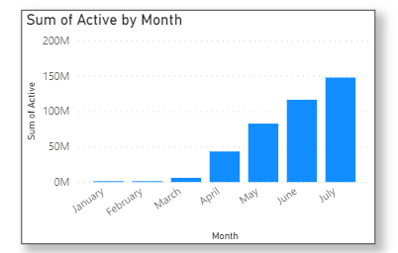

**Task 4: Create a Date filter**

Create a SLICER visual of date field AND SELECT BETWEEN from the dropdown of the visual

1. You can do your own formatting of font size, Data color, title, background

2. Make sure border is ON under formatting

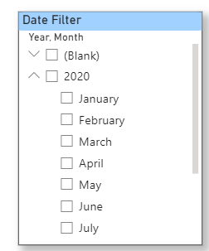

**Task 5: Create a Text filter**

Use GET MORE VISUALS From the visualisations, Search for TEXT FILTER visual. Create TEXT FILTER

visual for STATE field or COUNTRY field

1. You can do your own formatting of font size, Data color, title, background

2. Make sure border is ON under formatting

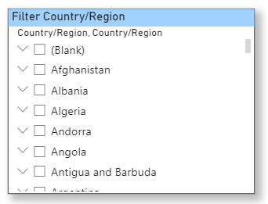

**Task 6: Create a table with country, state, DAILY cases, deaths, total confirmed cases, total deaths**

Create TABLE visual for Country, State, daily cases, deaths, total confirmed cases, total deaths

1. You can do your own formatting of font size, Data color, title, background

2. Make sure border is ON under formatting

Take screenshot of the visual and paste it in the Assignment submission template under task6

